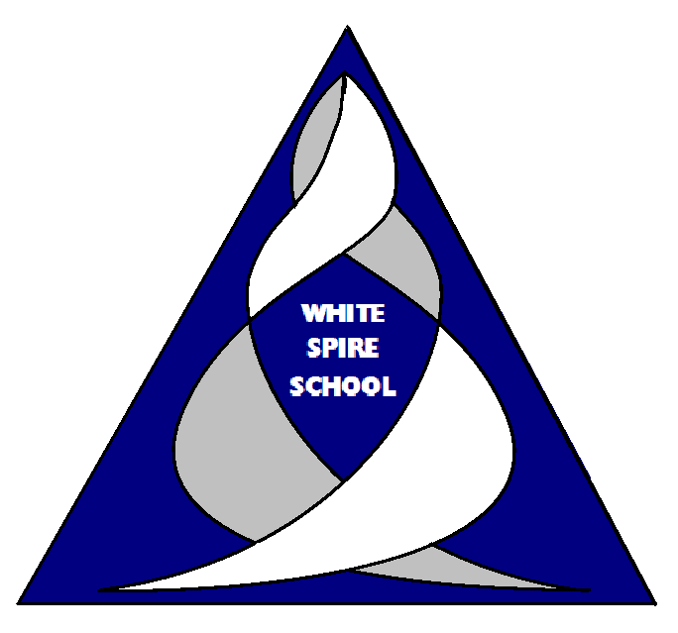

National Curriculum 2023-2024

A high-quality physical education curriculum inspires all pupils to succeed and excel in competitive sport and other physically demanding activities. It should provide opportunities for pupils to become physically confident in a way that supports their physical and mental health and fitness. Opportunities to compete in sport and other activities build character and help to embed a value led education.

Aims
The national curriculum for physical education aims to ensure that all pupils:
- develop competence to excel in a broad range of physical activities
- are physically active for sustained periods of time
- engage in competitive sports and activities
- Lead healthy, active lives.

PE and sport premium for primary schools
“At White Spire School we are committed to provide outstanding Physical Education to match all of our pupils needs. We are ensuring that the funding is spent on strengthening Physical Education and sustaining active play opportunities.”

We want the children to see that PE and sport are at the heart of school life and that they can achieve anything with hard work and a proactive mind-set.

We believe physical education and sport is an essential part of every child’s development. We endeavour to provide high quality physical education and sporting opportunities for every child, equipping them to lead healthy, active lifestyles as well as providing the children with the necessary skills of good sportsmanship, to strive for excellence and be resilient in defeat.

We aim to offer a balanced programme and a variety of activities to provide all pupils with the opportunity to develop a broad spectrum of skills, the knowledge necessary to use those skills throughout their lives whilst enabling them to develop acceptable fitness levels. We want to raise the aspirations of every pupil, providing them with the determination and enthusiasm to pursue a healthy and active lifestyle in future years.

What is the PE and sport premium for primary schools?
The PE and sport premium is designed to help improve the quality of the PE and sport activities that we offer to our pupils.
This document will explain how much money White Spire has received and what we have used the money for as part of the primary physical education and sports premium grant.
Sports Funding Allocation and Plan
Financial Year | Allocation | Spent | Carried Over
2022-2023 | £16,289.00 | £3,348.86 | £16,065.44
2023-2024 | £16,300 | £32,351.04 | £14.40

Breakdown off costs 2023-2024
Area | Spent
Top-up swimming  Staff CPD/Partnership  Ragdolly Anna’s staff training and clubs (dance)  Swing ball club  Kinball  Wellbeing activities  Wheelchair sports  Circus skills (coordination)  Cross curricular PE (More opportunities)  Total | £16,905.18  £7,600.00  £1,344.00  £239.88  £630  £1252.07  £2,200  £330  £1,849.91  £32,351.04  Left: £14.40

Key achievements 2023-2024
This template will be completed at the end of the academic year and will showcase the key achievements schools have made with their Primary PE and sport premium spending.
Activity/Action | Impact | Comments/Sustainability
Increased confidence, knowledge and skills of all staff in teaching PE and sport  -CPD for both PE staff and afterschool club  -Resources used for lessons  -After school support/resources/training | Staff more confident to lead a range of activities.  Resources support with leading lessons.  After school club staff has a rotation of activities planned via a trained staff member.  After school club have had training on the key activities which has given further confidence. | Ongoing Professional development/ access to a wide range of resources long term.  Trainer staff can impart knowledge onto new staff running activities and have the resources to support this.
Engagement of all pupils in regular physical activity  -Sporting activities outside of school  -After school activities  -Break/lunch time activities | Pupils are taking an active part in a wide range of activities within PE, break and lunches.  Pupils have a wider variety of activities to take part in and rotate daily.  Pupils are encouraged to participate and pupil voice has been taken into consideration. ie female pupils were not comfortable playing set games against male pupils. Girls activity club was put into place lunch time to support this. | There is an active school program in place. Activities can be evaluated termly and continue to progress.
The profile of PE and sport is raised across the school as a tool for whole school improvement  -Wellbeing activities  -Pathway to Paris  -Sports week (linked to science/food/art/PE)  -Student council voice  -Further PE opportunities in Mathematics. | Carousel of activities available break and lunch times.  Activities linked to lessons for greater learning opportunities.  School council was use for the pupil voice and what activities/equipment they would.  Pupils take part in a range of activities that support fitness and wellbeing. | Continue to use pupil’s voice to see what pupils are interested in/what they would like to try.  Use resources available to support this.
Broader experience of a range of sports and activities offered to all pupils  -Kinball (indoor/outdoor)  -Dance  -Mini golf  -Walking  -Wellbeing activities  -Circus skills (coordination)  -Wheelchair sports  -Swing ball | Large uptake of activities.  Outside activities also provide CPD for staff.  Activities support physical as well as mental health.  New activities promote team work and social skills.  Activities provide equal opportunities for all pupils.  Targets activities encourages our least active to participate. | Staff are trained and are able to continue to lead individual activities.
Increased participation in competitive sport  -Intra form (Dance offs, football, basketball, capture the flag, Kinball)  -Girls club  -MK partnership competitions | Pupils have taken part in sport outside of school.  Pupils who are not confident in playing competitive sport have had the opportunity to play competitive matches within school.  Targeted activities for individual groups have increase uptake. | Continue to evaluate and put on a range of activities.  Continue to develop links with other suitable schools.

Swimming Data
Meeting National Curriculum requirements for swimming and water safety.
Priority should always be given to ensuring that pupils can perform safe self-rescue even if they do not fully meet the first two requirements of the National Curriculum programme of study

Question | Stats: | Further context  Relative to local challenges
What percentage of your current Year 6 cohort can swim competently, confidently and proficiently over a distance of at least 25 metres? | 29% | Have had issues with getting pool space-Due to this, we were able to hire out a pool slot for the year.
What percentage of your current Year 6 cohort can use a range of strokes effectively [for example, front crawl, backstroke, and breaststroke]? | 29% | All pupils have an EHCP and have individual needs. Extra swimming has supported all individuals.

What percentage of your current Year 6 cohort are able to perform safe self-rescue in different water-based situations? | 29% can self-rescue  (float, tread water, raise arm and shout for help)  100% can respond to SAFE rules, | All pupils can respond to SAFE rules.  100% can safe self-rescues if given a floatation device.
If your schools swimming data is below national expectation, you can choose to use the Primary PE and sport premium to provide additional top-up sessions for those pupils that did not meet National Curriculum requirements after the completion of core lessons. Have you done this? | Yes/No | We provided extras swimming lessons for pupils in the year 6 cohort.  Pupils were able to work in smaller groups and have an area hired out specifically for the cohort.  Pupils completed two swimming lessons a week.
Have you provided CPD to improve the knowledge and confidence of staff to be able to teach swimming and water safety? | Yes/No | Pupils are taught by staff trained by the school who are aware of pupil’s individual needs and how to best support pupils.

Signed off by:

Head Teacher: | Finlay Douglas
Subject Leader or the individual responsible for the Primary PE and sport premium: | Michelle Bartle
Governor: | Neil Griffiths
Date: | 1st July 2024

